Your comments –

“I **don't particular care for the form the way your team has it now, it looks more like a paper format rather than a system. I am sure it will come together in the end.** ”

As per your given order form (Please see below) we have designed the work order request form for our system but only difference is the setting/placement of some fields. We have done the Work order request form for our system by considering the best suitable for responsive (i.e. for Iphone, iPad friendly).

Below is the screenshot of your order form. We have some logical queries based on this form. Please see below the queries and provide your esteem suggestions.

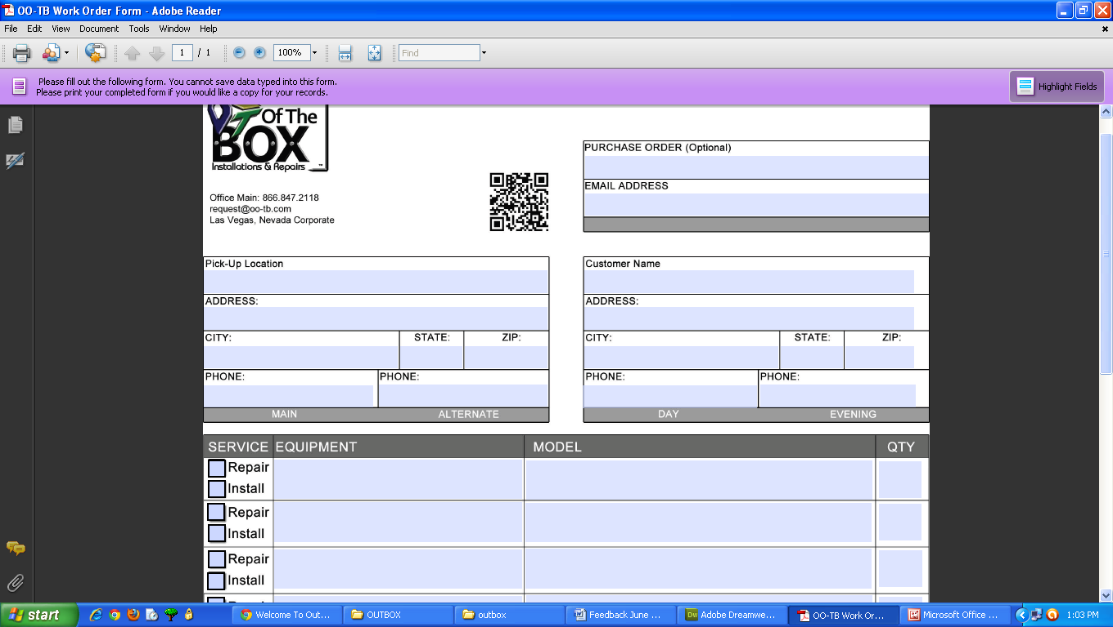

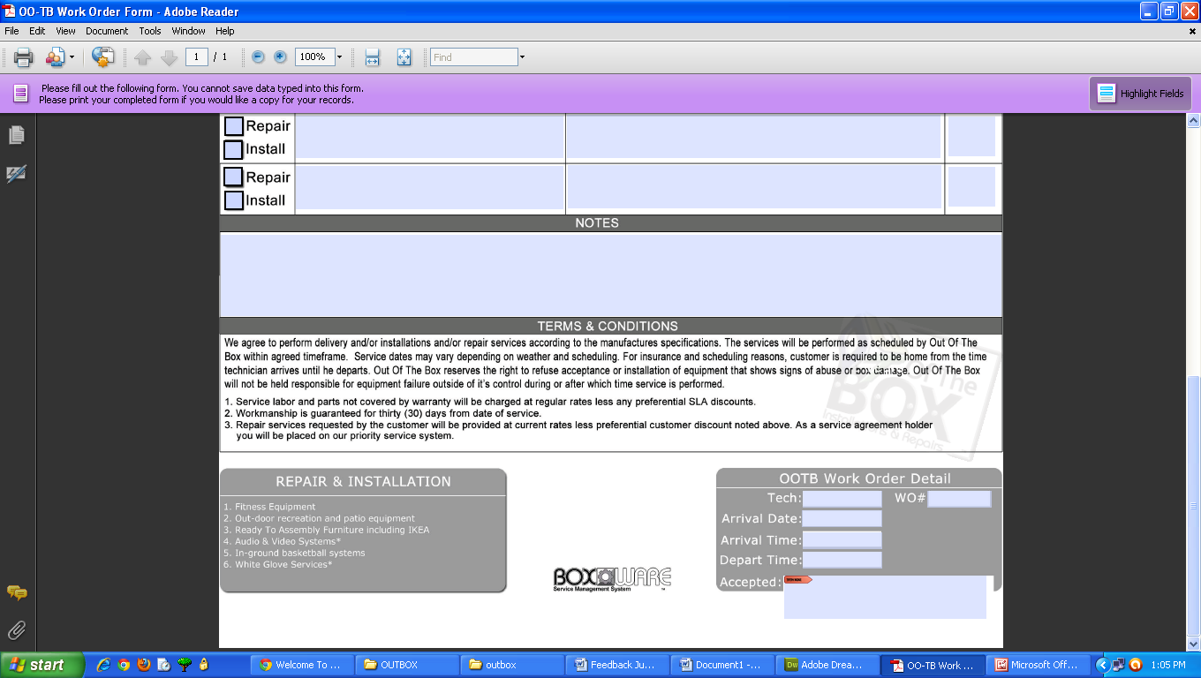

We think in the order form (what you have provided) some informations has been mentioned in a wrong way if you think logically on this.

Regarding the technician section in the right hand side bottom of the work order request form, we think logically this section should not be present in this work order request form. This should be placed under the service call section as “Assign job to Tech”.Please suggest.

See Skype conversation:

don’t worry about the workorder form, only about the fields that are in it. The page could be eliminated as it is in Boxware "post job" and be incorporated as a "new job" with the same fields as "open job" and "Scheduled Job" Only that some fields will be blanks at times, especially in the open job as an example the tech field will be blank as well as scheduled

**Query 1.**

In Email address field we can give autosuggestion for existing customers but for new customer some fields are different from the add client form. Below is the screen shot of add client form we have created before.

Can we equalize the two forms for customer details? Give your suggestion for us.

**“Yes”**

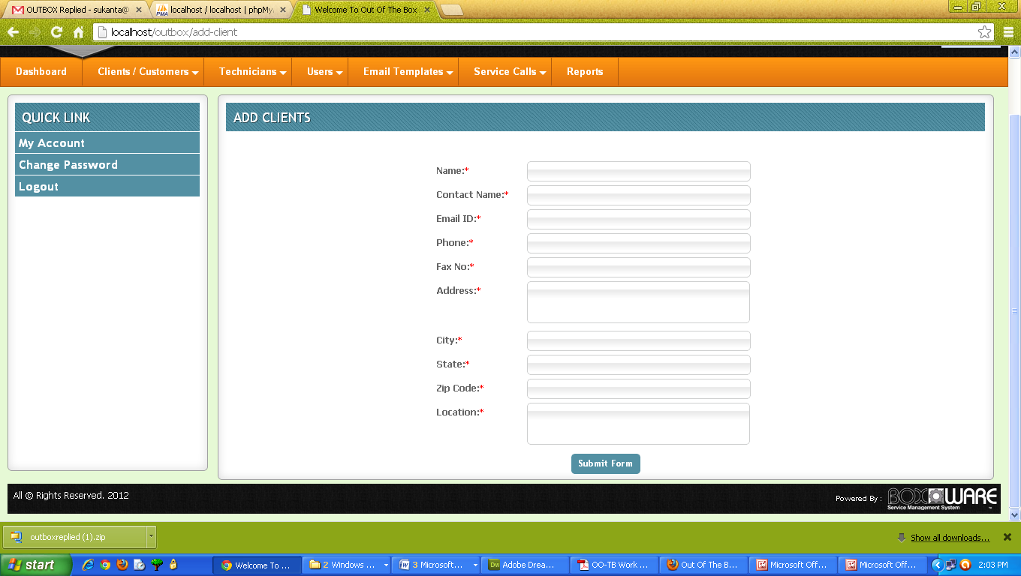

**Query 2.**

In the below part of the form Technician name and WO# field is present. I.e. we have to enter technician name and WO number while submit the work order request form?

**Don’t have to, while sometimes when a job is created, we will already know the tech doing the job, keep in mind that it could change if the tech is a no show or find out he can’t’ do the job.**

But logically if you think, we assign the Technician while requesting the form, then that job will be assigned to that Technician.

So, by considering the above thing ,please think how can we maintain the status of the Jobs as Open, Scheduled/Dispatched etc? Please suggest us regarding the process in detail. This is the vital part of the section.

**Solved with “Other system access”?**

**Query 3.**

You have given us the dispatch board and job details image of other system. We got it and trying to develop like this. Some more fields are present in these images.

Can you give us the link and the credentials of the other system as reference? So that we can navigate each section of the other system and can better known about the system.

This is because for some stuffs you have provided only the screenshots of the other system and from there one cannot guess clearly the exact flow of the other system. So for that reason if possible please share the link and credentials of the other system. **DONE**

**Query 4.**

In the work order form (Please see the above work order screenshot what you have provided) there is one Purchase Order filed (optional) and below WO# field which is mandatory.

Logically, if someone gives these two fields, then what is the role of both of these in the system? Can you explain us the important logic exists behind these two fields?

**Purchase Order is pertaining to the number that the customer gives us “when the customer is a business”**

**As an example, when a fitness manufacture sends us a job request, they will have a number assigned to it for “their tracking purpose”**

**We then create the job which results in a “Work Order Number”**